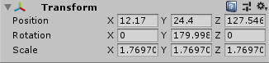kobe house1 main door transform

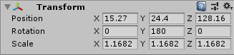kali house1 main door transform

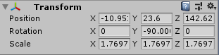kobe house1 side door transform

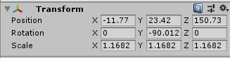kali house 1 side door transform

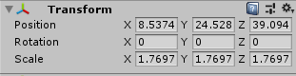kobe spawn

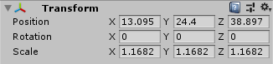kali spawn

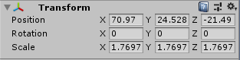kobe main door into house 1 transform

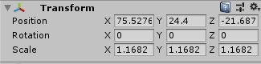kali main door into house 1 transform

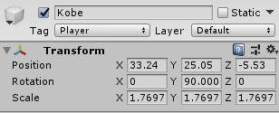kobe side door into house 1 transform

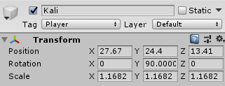kali side door into house 1 transform

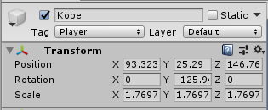kobe main door out house2 transform

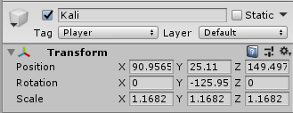kali main door out house2 transform

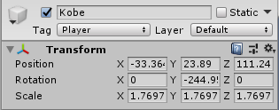kobe main door out house3 transform

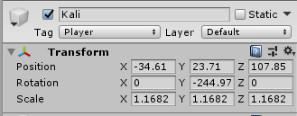kali main door out house3 transform

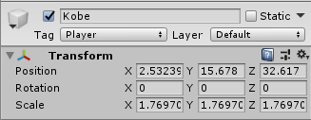kobe main door into house2 transform

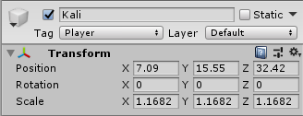kali main door into house2 transform

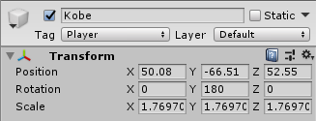kobe main door into house3 transform

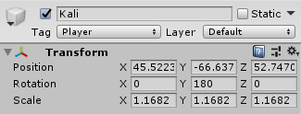kali main door into house3 transform